EN | Thank you for choosing TurboBrew Electric Vacuum Coffee Maker!

Cautions and Reminders Before First Use
To ensure safe and reliable use of TurboBrew, please read the following precautions carefully:

- TurboBrew is built with water-resistant design suitable for daily use and splash exposure. It is not intended for full submersion or prolonged contact with water. Avoid immersing the device in any liquid.
- After use or cleaning, dry TurboBrew thoroughly before storing. Keep it in a cool, dry place to maintain optimal performance.
- DO NOT disassemble or modify the upper brewer. It is sealed to preserve its dust- and splash-resistance. Tampering may affect the performance.
- TurboBrew is designed specifically for brewing coffee and tea. Use for other purposes may result in malfunction or damage.
- DO NOT exceed a maximum of 300ml in total each brew cycle—especially during manual mode, where segmented brews may lead to accidental overfilling. Exceeding the limit may cause overflow or allow hot liquid to exit through the pneumatic vent, creating a potential burn hazard.
- Keep the device upright during operation. Tilting, leaning, or shaking may block the pneumatic passage and disrupt the brewing process.
- Handle with care when assembling. Securely thread the upper brewer to the lower thermos cup without applying excessive force.
- Handle the USB-C charging port with care. Avoid excessive force or inserting sharp objects into the port to prevent damage.
- Keep out of reach of children. TurboBrew contains electrical components and is not intended for use by unsupervised minors.
- Hot liquid warning: Allow the coffee to cool slightly before drinking directly to avoid burns.
- Avoid use near open flames, flammable gases, or in hazardous environments.
- Inspect before each use. Do not use the device or charging cable if visibly damaged.
- Use only certified (UL/GS or equivalent) adapters with an output of 5V DC.
(Note: A USB adapter is not included.)
- Improper use or failure to follow instructions may result in injury, damage, or product failure. The manufacturer assumes no liability for misuse.

Product overview
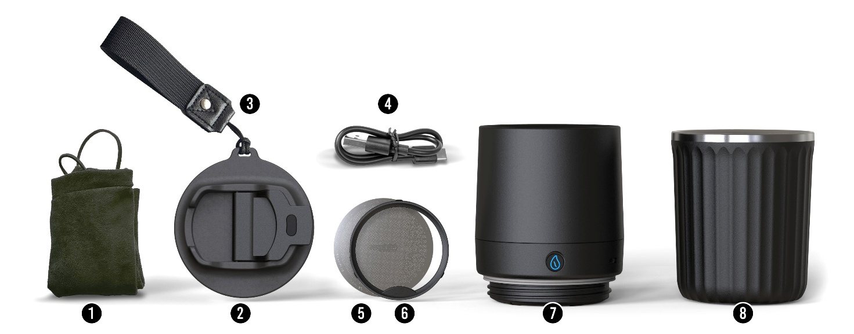

A full set of TurboBrew should include

- Soft carrying pouch | - Direct drinkable cap
- Hand strap | - USB to USB-C charging cable
- Stainless steel hyper filter | - Lock ring for hyper filter
- Electric upper brewer | - Lower thermos

how to recharge

Charging Instructions
- Connect the USB-A to USB-C charging cable to a certified USB power adapter (not included).
- Insert the Type-C end into the charging port located next to the power button. Ensure the connector is fully and securely inserted.
- While charging, the battery indicator light will display orange.
- Once fully charged, the indicator will turn blue.
- A full charge takes approximately 30 minutes.

Low Battery Warning: If the indicator light flashes orange during use, the battery is low. Please recharge as soon as possible.

Charging & Safety Precautions
- Before connecting the device to a power source, ensure that the charging port, cable, and adapter are completely dry to prevent electrical hazards.
- Always disconnect the device from the power supply if it will be left unattended for extended periods.
- Before each use, check that the charging cable and device are in good condition. Do not use if the cable is frayed, damaged, or compromised.
- This product is compatible only with UL, GS, or equivalently certified USB adapters with a 5V DC output.
- This device contains a rechargeable lithium-ion battery. To maintain battery health, charge the unit at least once every three months when not in use.
- Do not attempt to replace or disassemble the battery. For safety and performance, use only as directed.

How to use auto brew mode

TurboBrew is designed to be foolproof—the default mode is automatic brewing, so all it takes is a single press of a button. Before you start, a few simple preparation steps are required:

- Assemble the Device  a. Place the Hyper Filter into the base of the upper brewer, ensuring the correct side is facing up. Secure it in place with the lock ring, making sure it is properly seated in the groove.  b. Next, thread the upper brewer onto the lower thermos cup and tighten firmly to ensure a secure, leak-proof seal. | 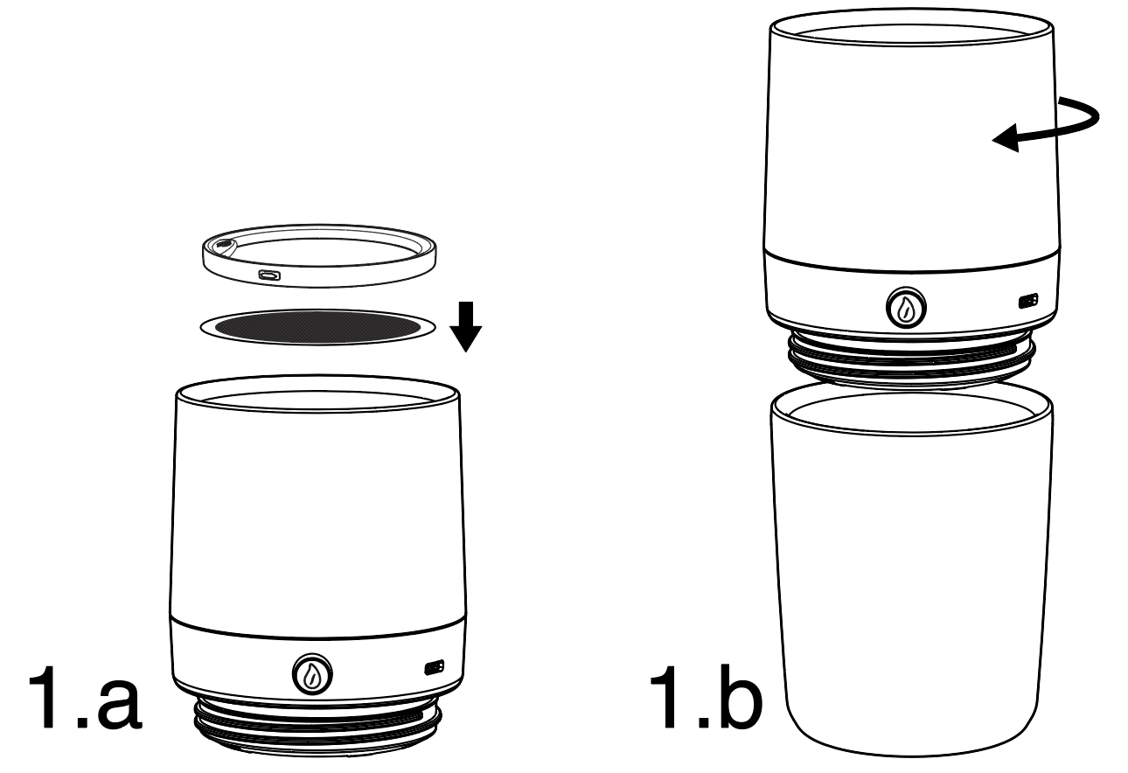
- Prepare Coffee Grounds  Add your preferred coffee grounds to the filter (refer to the “Grind Size Guide” section for recommendations). | 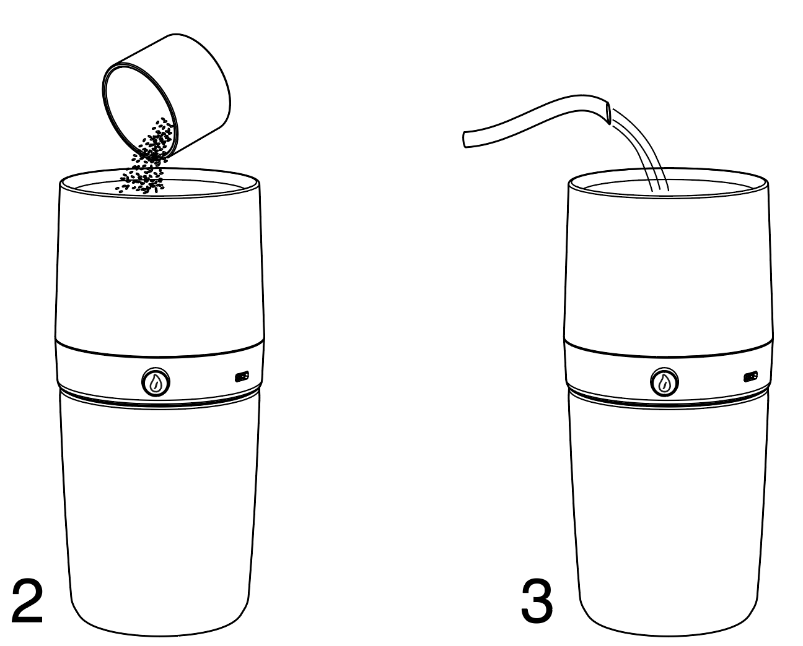
- Add Hot Water
Prepare hot water—boiling water is recommended.

- Start Brewing  Press and hold the power button for 2 seconds.  The LED indicator will turn blue  You’ll hear a double beep, confirming that your input has been registered  TurboBrew will begin the automatic brewing cycle | 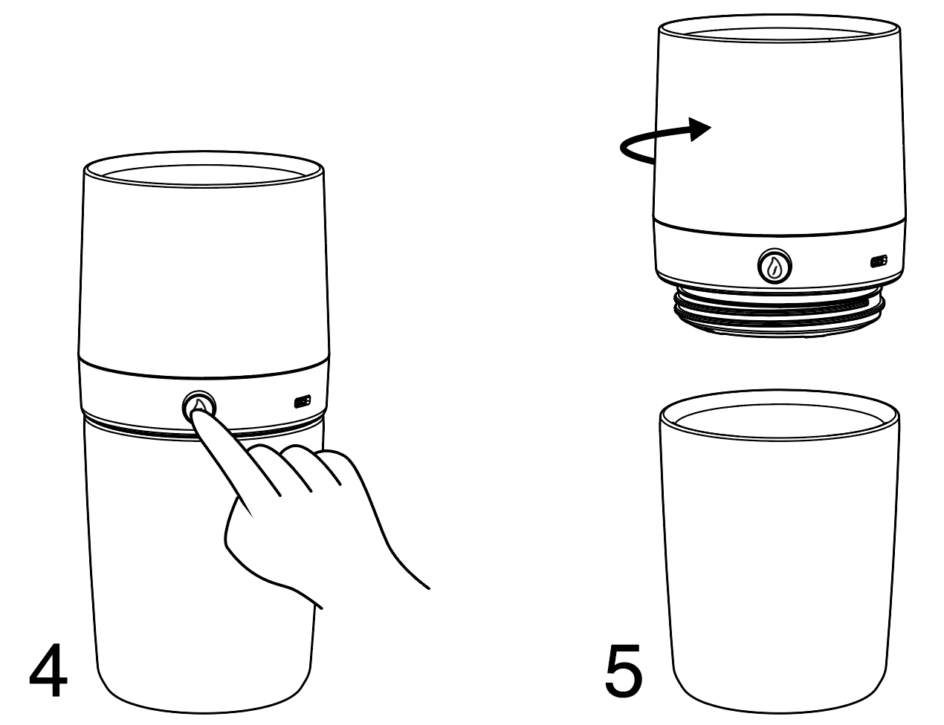
- Enjoy
Once the brewing is complete, your coffee will be automatically transferred into the lower thermos cup, where it will stay warm until you're ready to enjoy it.

Tips:
Take your time—just don’t leave your coffee waiting too long. Fresh is best!

Caution: Hot liquid
Allow the coffee to cool slightly before drinking directly from the thermos cup to avoid burns.

How to use manual mode

We encourage users to experiment with Manual Mode to explore and fine-tune the brewing process based on personal taste preferences. This mode allows you to control the timing of extraction, unlocking new possibilities in flavor and body.
To enter manual mode, simply interrupt the automatic brewing cycle by pressing the power button at any desired point after activation. Once interrupted, TurboBrew will switch to manual mode, allowing full control over when extraction begins.

Step-by-Step Instructions:

- Assemble the Device
Place the Hyper Filter into the base of the upper brewer, ensuring the correct side is facing up. Secure it in place with the lock ring, making sure it is properly seated in the groove.
Next, thread the upper brewer onto the lower thermos cup and tighten firmly to ensure a secure, leak-proof seal.
- Prepare Coffee Grounds
Add your desired amount of ground coffee into the filter. (Refer to the “Grind Size Guide” for best results.)
- Enter Manual Mode
Press and hold the power button for 2 seconds to power on TurboBrew. To switch from Auto Brew to Manual Mode, double press the button as follows:
- The first press stops the auto countdown and immediately starts the turbo filtration process.
- The second press stops the filtration and puts the device into manual standby mode.
To ensure proper recognition, wait at least 2 seconds between the two presses.
- Start Manual Brewing
In manual mode, you can create a segmented brewing cycle by pressing the button once to start or pause suction. This allows you to customize strength and flavor based on your timing and preference.

Pro Tips:  - For enhanced extraction, try gently stirring the brew during the immersion phase. Experiment with timing and techniques to fine-tune your perfect cup.  - To achieve a cleaner, more refined taste, consider adding a paper filter and lock screen (*available as optional accessories). These can help improve clarity by filtering out finer particles even lower than 150 microns. | 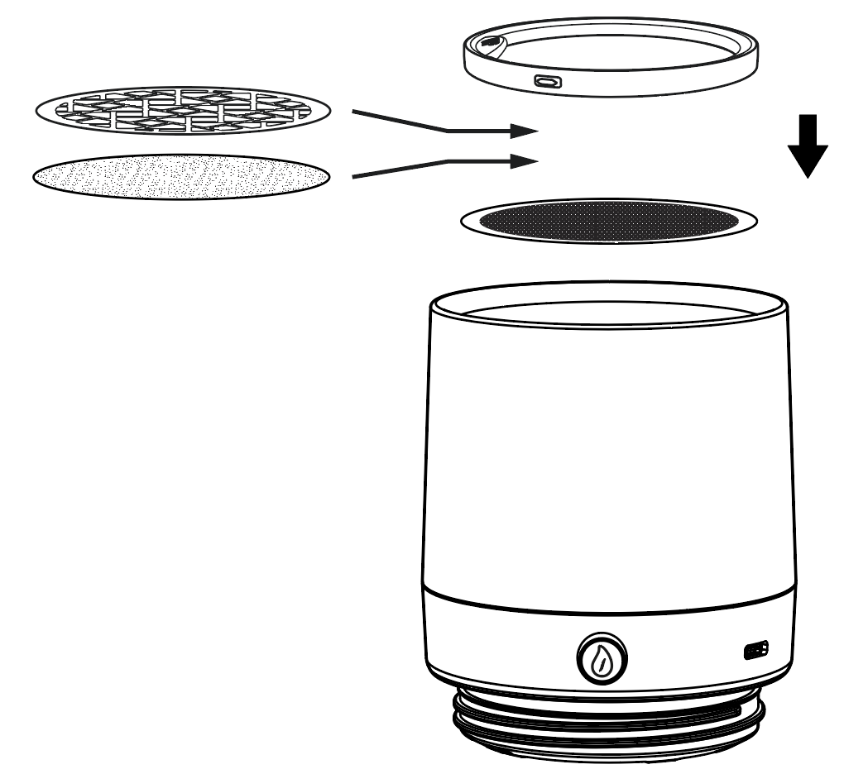

what grind size Do i choose

TurboBrew is compatible with a wide range of grind sizes, thanks to its precision-engineered stainless steel hyper filter with a mesh size of 150 microns.
For optimal performance and flavor, we recommend using coffee grounds in the range of pour-over to French press size, approximately 600 to 1400 microns.

This range provides the best balance between clarity and body, allowing for smooth extraction while minimizing clogging or over-extraction.

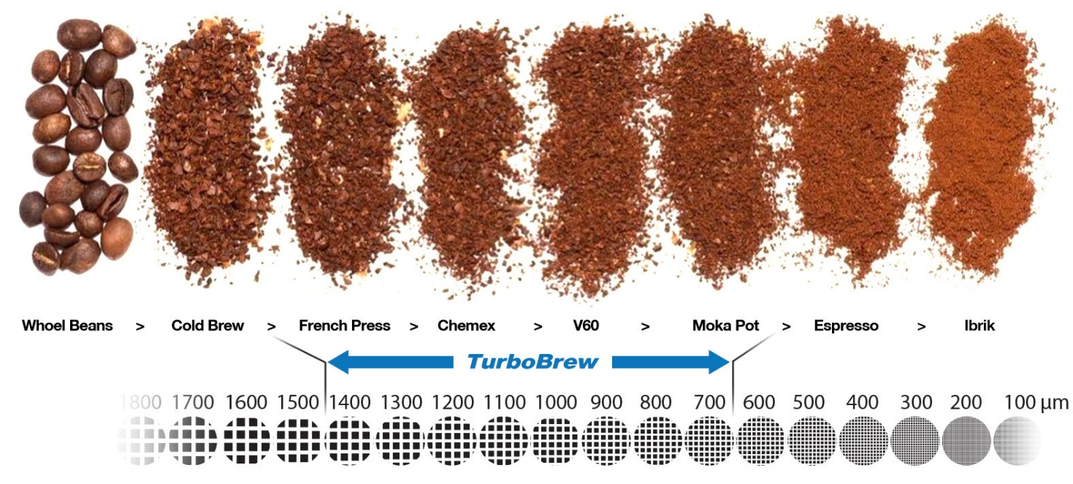

understand the Button actions, beeping & lighting patterns

Each time you press the button, TurboBrew emits a confirmation beep to acknowledge your input.

A built-in LED indicator will also display different lighting patterns and colors to reflect the current operation status.

EVENT | Button  Action | Indication Sound | Indication  Light | Description
Power  ON | Long Press | ● ● |  | To Power on, press and hold the button for 2 seconds. Two short beeps will sound, and the blue LED will flash once per second, indicating Auto Brew mode has started.  Note: Pressing the button cancels Auto Brew and starts suction.
AUTO  Immersion  Brew | NA | NONE |  | Blue LED continues flashing once per second during the 3-minute immersion countdown.  Note: Pressing the button cancels Auto Brew and starts suction.
AUTO  Suction | NA | ● |  | After the countdown, suction starts automatically. One short beep sounds, and the LED turns into solid blue for 30 seconds.  Note: Pressing the button cancels Suction and enters Standby mode.
Standby  /Pause  Suction | NA / One Press | NONE |  | Pressing the button once during suction to pause and standby. Confirmed by one short beep; LED enters breathing mode. Press again to resume suction.
MANUAL  Suction | One Press | ● |  | In Auto Brew or Standby Mode, a single button press starts a 30-second suction cycle. One short beep sounds, and the LED turns into solid blue. Returns to Standby after completion.
Low  Battery | NA | NONE |  | LED flashes rapidly in orange. Brewing is still possible, but charging is recommended immediately after.
Charging | NA | NONE |  | While charging, the LED remains solid orange. No flashing or sound during charging.
Fully  Charged | NA | NONE |  | The LED turns into solid blue once fully charged.
Power  OFF | Long Press | ●— |  | Press and hold the button for 2 seconds to power off the device. A long beep sounds, and the LED turns off.
AUTO  OFF | NA | ●— |  | If inactive in Standby Mode for 5 minutes, TurboBrew powers off automatically. A long beep sounds, and the LED turns off.

Cleaning and Maintenance

Cleaning TurboBrew is quick and easy—just follow these simple steps to keep your device in great condition and ensure optimal performance over time:

Before Each Brew
Rinse all components with clean water to ensure the device is free from any residue or dust.

After Each Brew
Dispose of the used coffee grounds immediately into a trash bin to avoid coffee oil buildup.
Be careful not to accidentally throw away the Hyper Filter or Lock Ring when emptying the brewer.
Rinse all removable components under running water.
If you notice excess coffee oil buildup, you may use a small amount of mild detergent to clean the parts.

Handling the Upper Brewer
Do not submerge the upper brewer in water. While TurboBrew is water-resistant, it is not designed to withstand full water pressure or immersion, which could compromise its internal seals and reduce its lifespan.

After Cleaning
Dry all parts thoroughly before storing to help preserve the device and maintain performance.

Dishwasher Notice
🚫 TurboBrew is not dishwasher safe. Please hand wash only.

trouble shooting

Q1: I pressed the button, but there’s no beep. What’s wrong?
First, check the LED indicator. If there’s no light at all, your press likely wasn’t registered—try pressing the button again, firmly.
If the light is on and blinking once per second, TurboBrew is functioning normally. The issue may be a beeper malfunction. Don’t worry—this won’t affect performance. You’ll simply lose the sound notification, but the brewing process will still work as intended.

Q2: Why is there still water left in the upper brewer after the auto-brew finishes?
This could happen if the coffee grounds are too fine, which may slow down the flow rate. The built-in suction system is programmed to extract for a fixed cycle. If there's excess water remaining, simply press the button once more to activate an additional suction cycle and transfer the remaining liquid into the thermos cup.

Q3: My coffee looks cloudy. Is something wrong?
This is likely caused by coffee grounds that are too fine. TurboBrew’s Hyper Filter captures particles above 150 microns, but that doesn’t mean your grind should be set that fine. Unless you sift your grounds, most grinds will include a significant amount of smaller particles. For optimal extraction and balanced flavour, we recommend a grind size of at least 600 microns (approximately levels 13–17 on most manual grinders; actual settings may vary by brand). This ensures a smooth mouthfeel with rich flavour.
If you are looking for an ultra-clear brew, consider using a round paper filter along with the lock screen (*available as optional accessories).

Q4: Why can’t I use TurboBrew while it’s charging?
This is a built-in safety feature. TurboBrew automatically disables brewing during charging to prevent overheating and protect battery health. Charging takes only 30 minutes, and a quick 5-minute charge is usually enough for up to 5 brews—so your next cup is never far away.

Q5: What happens if I accidentally overfill the water or coffee grounds?
Overfilling coffee grounds? No issue—you’ll just get a stronger brew.
Overfilling water in AUTO mode? Still manageable. It may cause minor spillage, but the system will still function.
Overfilling water in Manual mode? Be cautious: TurboBrew is designed for a maximum of 300 mL in total per brew cycle. Exceeding this limit can lead to flooding or blockage of the pneumatic vents. If this happens, stop brewing immediately and safely discard the brew before starting again. To prevent accidental overfilling during segmented manual brews, we strongly recommend using a scale for better accuracy and control.

Q6: What if my child accidentally presses the button multiple times?
No damage done—just a little battery drain. Pressing the button during auto brew will switch the unit to manual mode, where button presses either pause the brew or trigger suction. A long press will turn the device off. It’s safe, but we recommend keeping TurboBrew out of reach of young children when not in use.

Read online

For the best viewing experience, open on desktop.

 | 
English | 繁體中文
Customer Service
hello@simplelab-exp.com

Community
Instagram @ simplelab.exp
Youtube @ simplelabexperience

